**PRIMARY SEVEN EXAMINATIONS 2019**

**MATHEMATICS PAPER**

*Time : 2:30minutes*

**Pupil’s name :……………………………………………… Index No……………........**

**SECTION MARKS**

**B**

**A**

**DO NOT OPEN THIS BOOKLET UNTIL YOU ARE TOLD TO DO SO**

**Read the following instructions carefully.**

**T**

1. **Read the instructions carefully**

1. **Answer ALL questions in Section A & B**
2. **Answers should be put in the space provided.**
3. **All answers should be written in blue or black ink.**
4. **Unnecessary alterations may lead to loss of marks**
5. **Any handwriting that cannot be read may lead to loss of marks.**

**SECTION A (40 MARKS)**

1. Divide 24 ÷ 4 using repeated subtraction.
2. Describe the unshaded part

**P Q**

1. Simplify; - 3 – + 8
2. Use distributive property to work out:

7.4 ÷ 2 + 2.6 ÷ 2

1. Find the value of **p** in degrees.

2p+400

1200

1. The perimeter of a rectangle is 7.6mm. If its width is a half of its length, find its length.
2. Express the number shown on the abacus below in Scientific notation.

**TH H T O**

1. A motorist covered 180km in 2 hrs. Express his speed in m/sec.
2. Name the polygon whose centre angle is 360.
3. Apio bought a dress at sh.18,000 and sold it at sh. 15,000. Calculate her percentage loss.

1. Without using a pair of compasses, draw an angle of 600.
2. Find the length of side PQ on the triangle below.

R

16cm

8cm m

6cm

P T Q

1. Express 0.3636… as a rational number.

1. The mean of (a+4), 2a, a+3 and 5 is 6. Find the value of a.
2. Set Q has 31 proper subsets. Find n(P).
3. Okello was born in 13BC and died in 36AD. How old was he?
4. Name the co-ordinates of point Q on the graph below

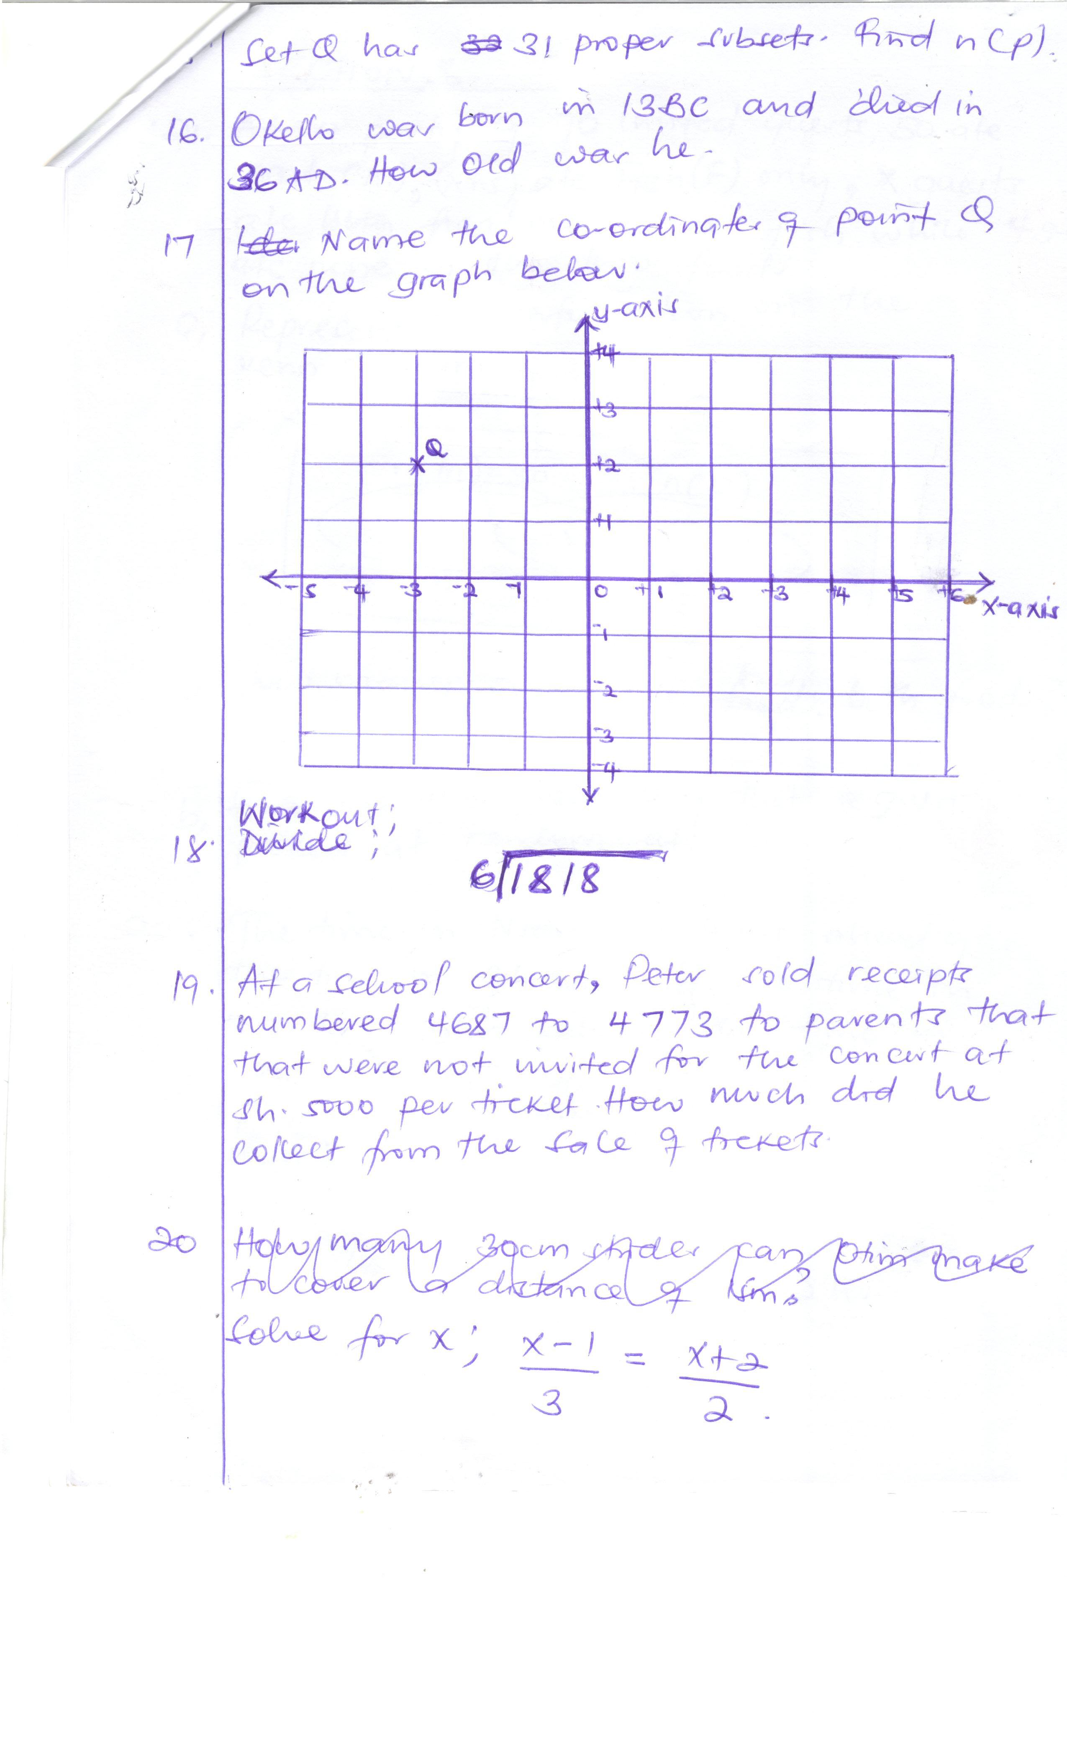

1. Workout: 6 1818
2. At a school concert, Peter sold receipts numbered 4687 to 4773 to parents that were not invited for the concert at sh. 5000 per ticket. How much did he collect from the sale of tickets?

**SECTION B (60 MARKS)**

1. At aparty of 70 invited guests, 50 ate Meat (M), (x+5) ate Fish(F) only, x guests ate meat and fish while 4 guests ate none of the two foods.

a) Represent the information on the venn diagram.

∑ = 70

n(M)=50 n(F)

_____ x ___

4

b) How many guests ate both foods?

c) Find the probability that a guest picked at random ate Fish.

1. The time in Nigeria is 4hrs ahead of the time in Ghana and the time in Uganda is 5hrs behind the time in Ghana.

a) Represent the three countries on a number line.

b) If the time in Uganda is 8:30am, find the time in Nigeria in 12 hr clock system.

1. On a farm,  of the animals are cows,  of the remainder are goats and there are 12 sheep.

a) What fraction are sheep? (4marks)

b) How many animals are on the farm? (2marks)

1. The frequency table below shows the marks scored by a group of children in their pre-mock examination in Kitto Primary School.

|  |  |  |  |  |
| --- | --- | --- | --- | --- |
| Marks scored | 85 | 90 | 70 | 80 |
| No. of children | 2 | 1 | 3 | 4 |

a) Find the modal frequency

b) Workout the median score.

c) How many children scored above the average score?

1. Mr. Musoke planted 480 eucalyptus tree seedlings in 3-days. If he planted 20 more trees on the next day.

a) How many seedlings did he plant on the first day?

b) Express the total number of trees planted on the second and third day in

words.

1. On the figure below, line AD is parallel to line EG and BCF is a triangle. Use it to answer questions that follow

A B C D

m 1200

p

E 500 G

F

a) Find the value of p.

b) Find the value of angle m.

1. a) Given that 103n = 28ten. Find the value of n.

b) Employees of BK company receive their salaries after every 31 days. If they

are paid on Tuesday this week; On what day of the week; on what day of the

week will they receive their next pay?

1. The table below shows the rate at which the bank buys and sells Us. Dollars and Kenyan shillings. Use it to answer questions that follow.

|  |  |  |
| --- | --- | --- |
| **Currency** | **Buys** | **Sells** |
| 1 Us dollar  1 Kenya shilling | Ug. Sh. 4,400  Ug. Sh. 34 | Ug. Sh. 4500  Ug. Sh. 35 |

a) If a trader has 200 Us dollars and K.sh. 400, how much money will he get from

the bank in Uganda shillings.

b) Opio had sh. 1,760,000 and wanted to exchange it with us dollars. How many dollars did he get from the bank.

1. a) Construct a quadrilateral PQRS such that PQ = 6cm, angle PQR = 1200 and QR = 4cm using a ruler, pair of compasses and a sharp pencil only.

b) Measure diagonal PR.

1. Okia is twice as old as Tom. In 10 years time, Okia will be twice as old as Tom.

a) How old is Tom now?

b) How old will Okia be in 16 years time?

1. a) A motorist needs 8 litres to cover a distance of 56km. How many litres will he need to cover a distance of 280km.

b) If 1 litre costs sh. 3600, how much will be spent of fuel to cover 280km?

1. 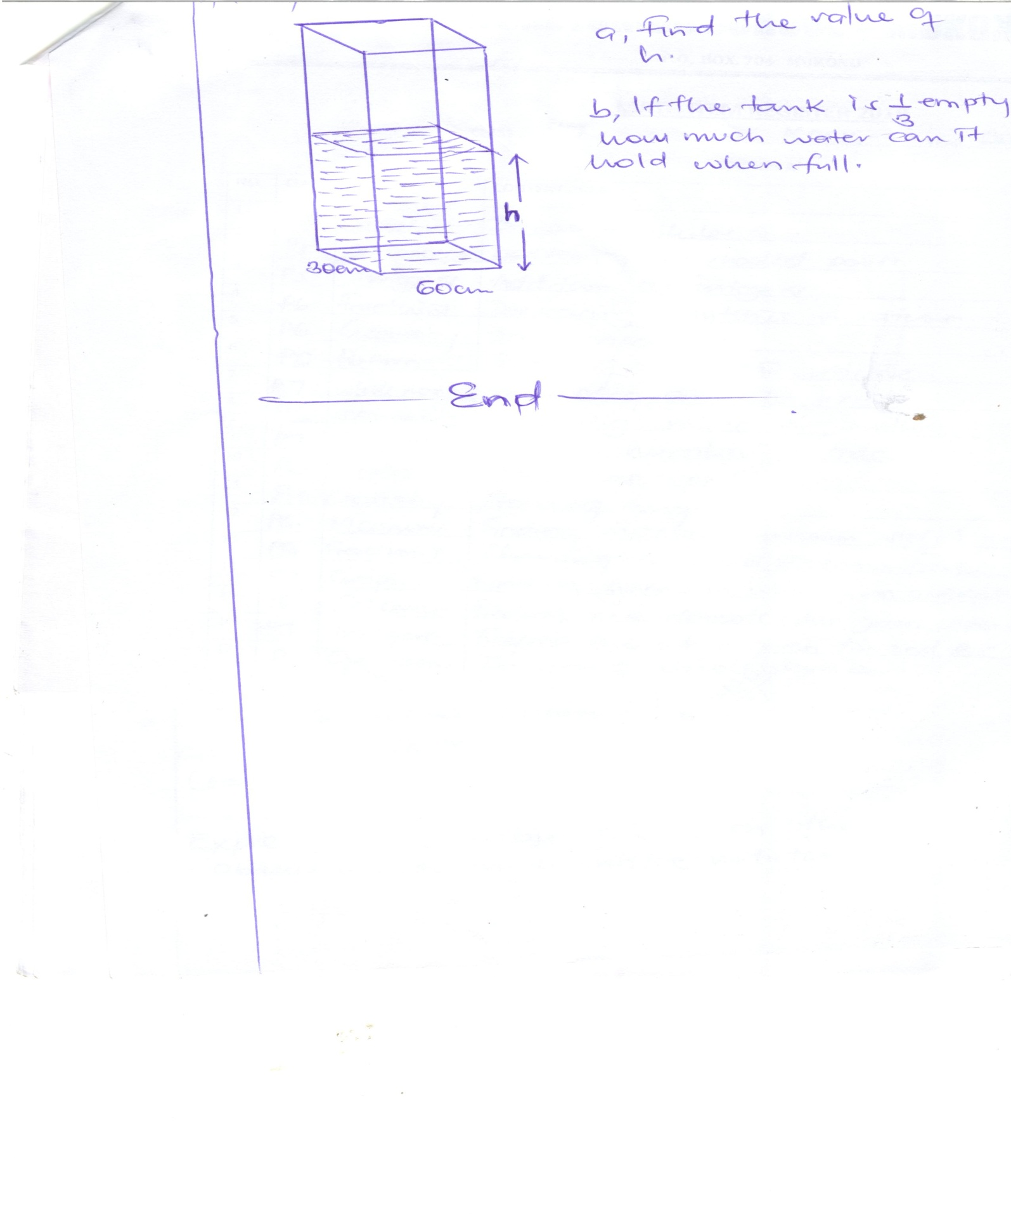The rectangular tank below is 72 litres full of water.

h

1. Find the value of h.
2. If the tank is empty, how much water can it hold when full.

**END**